
Subject: Programming with Java
ASSIGNMENT No : 23
TITLE: Develop a Java application using JDBC to navigate and retrieve records from a ResultSet.

Name: Avdhoot Mohite Class: CSE A2
PRN: 25070122056 Batch:25-29

Problem Statement
Develop a Java application using JDBC to navigate and retrieve records from a ResultSet.

Learning Objectives
To navigate and retrieve records using ResultSet methods.

Theory
A ResultSet object contains data retrieved from a database after executing a SELECT query. It acts like a cursor that points to one row of the result at a time. Initially, the cursor is positioned before the first row. Various methods such as next(), previous(), first(), last(), absolute(), and relative() allow movement through the records. Data from each column can be retrieved using methods like getString(), getInt(), and getDouble(). Scrollable and updatable ResultSets provide greater flexibility for navigating and modifying retrieved data. ResultSet plays a crucial role in displaying and processing database information in Java applications.

Exercise
- Create a program to display database records one by one using ResultSet.
CODE:

import java.sql.*;

public class assignment23a {
public static void main(String[] args) {

String url = "jdbc:mysql://localhost:3306/student_db";
String user = "root";
String password = "Avdrocks@0504";

try (
Connection con = DriverManager.getConnection(url, user, password);
Statement stmt = con.createStatement();
ResultSet rs = stmt.executeQuery("SELECT * FROM students ORDER BY id")
) {
System.out.println("Database connected successfully!");
System.out.println("Student Records:");

while (rs.next()) {
System.out.println("Student ID: " + rs.getInt("id"));
System.out.println("Name: " + rs.getString("name"));
System.out.println("Course: " + rs.getString("course"));
System.out.println("-----------------------");
}

} catch (SQLException e) {
System.out.println("Error: " + e.getMessage());
}
}
}

SQL:
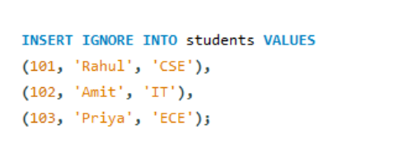

OUTPUT:
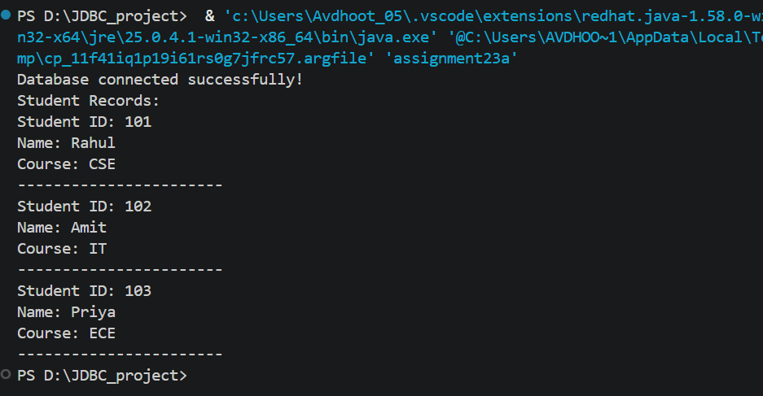
- Create a Java program that retrieves employee records from a database and displays them one by one using ResultSet. Show employee ID, name, department, and salary sequentially

Code:

import java.sql.*;

public class assignment23b {
public static void main(String[] args) {

String url = "jdbc:mysql://localhost:3306/student_db";
String user = "root";
String password = "Avdrocks@0504";

try (
Connection con = DriverManager.getConnection(url, user, password);
Statement stmt = con.createStatement();
ResultSet rs = stmt.executeQuery("SELECT * FROM employees ORDER BY emp_id")
) {
System.out.println("Database connected successfully!");
System.out.println("Employee Records:");

while (rs.next()) {
System.out.println("Employee ID: " + rs.getInt("emp_id"));
System.out.println("Name: " + rs.getString("emp_name"));
System.out.println("Department: " + rs.getString("department"));
System.out.println("Salary: " + rs.getDouble("salary"));
System.out.println("-----------------------");
}

} catch (SQLException e) {
System.out.println("Error: " + e.getMessage());
}
}
}

SQL:
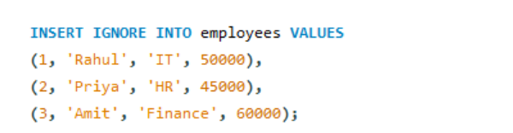
OUTPUT:
